### **Cowrywise Data Analysis Assessment Report**

**Objective:** To perform data analysis using SQL Server Management Studio (SSMS) by migrating and transforming data from a MySQL environment via Docker, with the help of PowerShell and SQL Server Migration Assistant (SSMA).

### **Tools Used**

* **Docker** – For containerization of the MySQL environment
* **PowerShell** – To inject and run the Docker container
* **SQL Server Migration Assistant (SSMA)** – To convert and migrate the MySQL schema and data to SQL Server
* **SQL Server Management Studio (SSMS)** – For running SQL queries and performing the analysis

### **Process Overview**

1. **Docker Container Setup** I started by creating a Docker container to host the MySQL environment. This allowed for a consistent and isolated environment for the source data.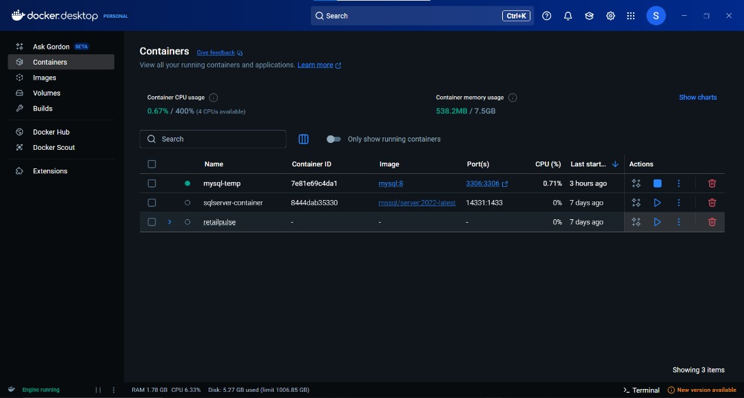

1. **Injecting Container via PowerShell** Using PowerShell, I injected and executed the container, ensuring it was running properly and ready for data extraction.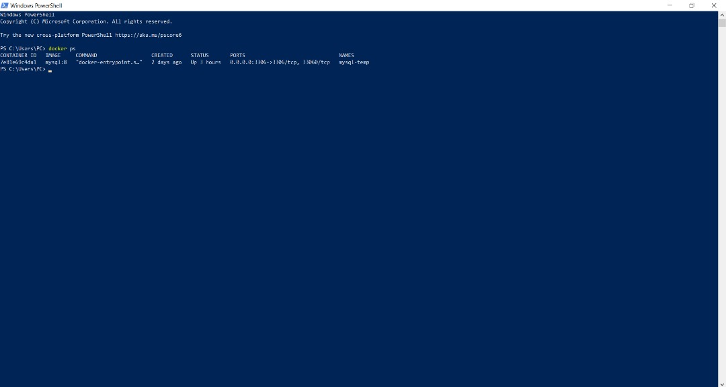

1. **Schema Conversion with SSMA** I connected the MySQL container directly to **SQL Server Migration Assistant (SSMA)**.  
   * I then **converted the MySQL schema** to a SQL Server-compatible schema.
   * After conversion, I **synchronized** the schema with the destination SQL Server instance.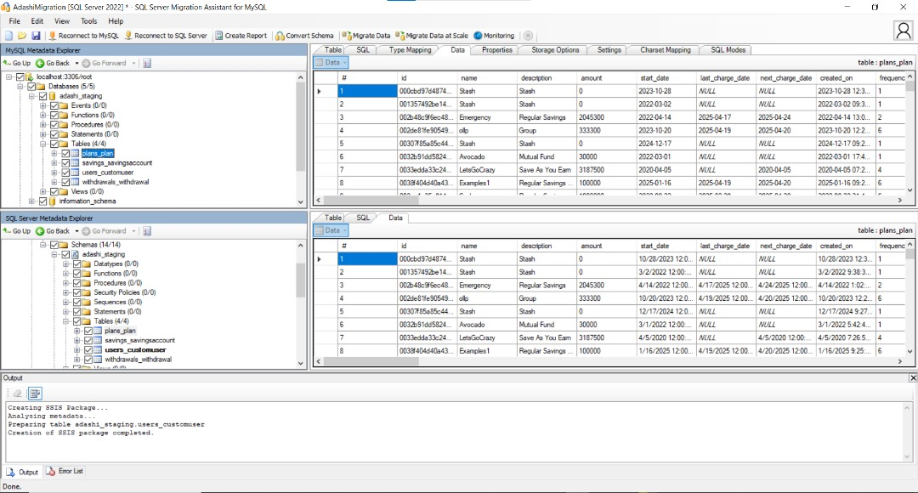
2. **Data Migration** Once the schemas were successfully synchronized, I proceeded to **migrate the actual data** from MySQL to SQL Server using SSMA.
3. **Handling Table Import Issue** During the migration process, I encountered an issue with the user_customer table which failed to migrate properly.  
   * To resolve this, I exported the table from MySQL into a **flat file** (CSV format).
   * I then **imported the flat file** into SQL Server using the **Import Flat File Wizard** in SSMS.
4. **Data Analysis in SSMS** With all necessary tables successfully migrated, I loaded the data in **SSMS** and began performing the required SQL queries and analysis.  
    This included data extraction, aggregation, filtering, and joining various tables to generate insights based on Cowrywise's dataset.

**QUESTIONS**

**1.High-Value Customers with Multiple Products**

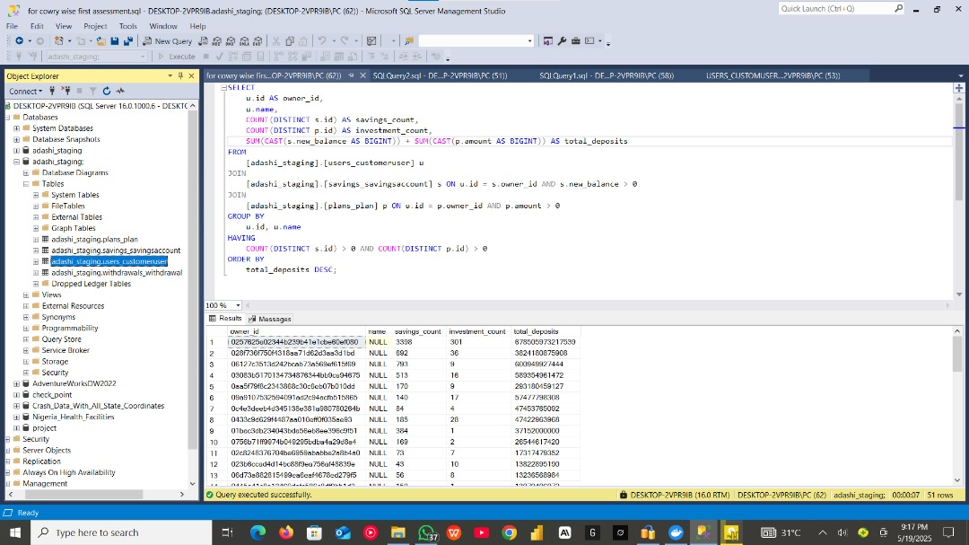

**2.Transaction Frequency Analysis**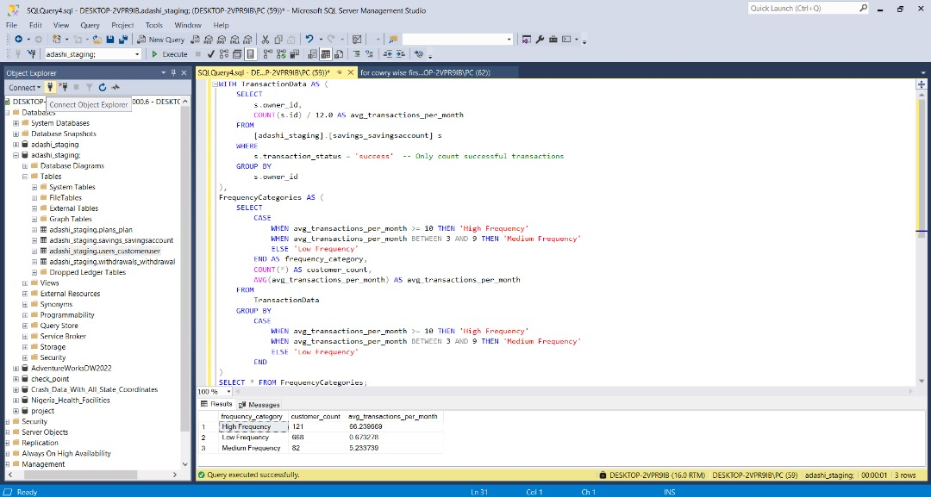

3.**Account Inactivity Alert**

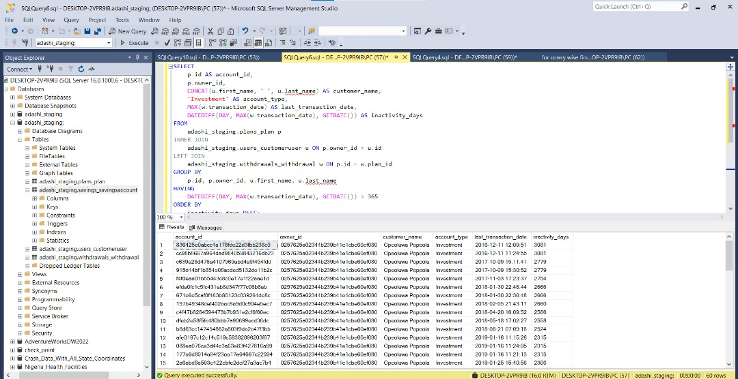

### **Conclusion**

This project allowed me to gain practical experience in containerization, cross-platform database migration, and handling real-world data import issues. It also strengthened my skills in SQL query writing and problem-solving within a data analysis workflow.